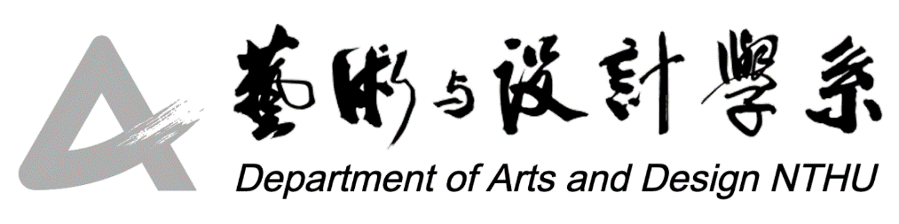

A+ Artist Residency Exchange Program

* 1. Objective

The program aims to invite resident artists/designers/curators or researchers to engage with students through their rich creative experiences, design practices, and research, with the goal of expanding students' horizons, encouraging interdisciplinary thinking, and infusing the department with artistic energy and vitality.

1. Application Requirements

Artists, designers, curators (including researchers) of any nationality who have at least 2 years of experience in artistic creation, design, curation, or research are eligible to apply.

1. Application Deadline

Applications will be reviewed on a rolling basis.

1. Required Documents

(1) "A+ Artist Residency Exchange Program Application Form" offered by Department of Arts and Design, National Tsing Hua University

(2) Portfolio of past artistic/design experiences and personal introduction presentation file (including personal photo, at least 10 images or audiovisual materials related to your works, and accompanying information such as title, dimensions, medium, and year).

1. Application and Submission

Applications should be sent via email, with the subject line indicating: “A+ Artist Residency Exchange Program_ Applicant's Name.” Send the required documents to: artist@my.nthu.edu.tw.

1. Notes

(1) If it is found that the materials submitted by the applicant (including artwork images) contain false information or infringe upon the rights of others, the qualification will be immediately withdrawn, and the applicant shall bear any legal responsibilities incurred.

(2) Selected applicants must agree to provide the relevant texts, images, or audiovisual materials requested by the department for educational and promotional purposes, and agree to participate in related activities arranged by the department."



A+ Artist Residency Exchange Program Application Form

|  |  |  |  |  |  |
| --- | --- | --- | --- | --- | --- |
| Name | （Chinese）　　　　　　（English） | | | | Personal Photo |
| Birthday | (Year/Month/Day) | Gender | □Male  □Female |
| Mailing Address |  | | | | |
| Contact Number | （Office）  （Home）  （Mobile） | | | | |
| E-mail |  | | | | |
| Educational Background and Significant Exhibition/Design/Curation/Research Experience | *Please include a personal resume along with details of exhibitions, designs, curation, and research experiences from the past 3 years. (Please provide bilingual information in Chinese and English, up to 2 pages) | | | | |
| Proposal of *A+ Artist Residency Exchange Program* | *Please write in both Chinese and English, including personal introduction, project title, *A+ Artist Residency Exchange Program* details and schedule, with a maximum of 1000 words.   1. Personal Background Introduction   (Maximum 300 Chinese characters/ Maximum 500 English words)   1. Project Title 2. Proposed A+ Artist Residency Exchange Program details and schedule   (Maximum 300 Chinese characters/ Maximum 500 English words) | | | | |
| References | * Personal portfolio in electronic format (bilingual in Chinese and English), personal website, catalogue in electronic format, or relevant materials such as reviews, design research, etc. (Chinese and English are both acceptable). | | | | |
| Emergency Contact | Name:  Relationship:  Contact Information: | | | | |

To: Department of Arts and Design, National Tsing Hua University

Applicant Signature:

Date (Year/Month/Day):